**Assignment 4**

**Swapnil Kamate**

**Note: Questions are not in order as I did them according to my free time. Like easy first and time consuming on later. Sorry about this.**

**Chapter 5**

4)Given the following business scenario, create a Crow’s Feet ERD using a specialization hierarchy if appropriate. Two-Bit Drilling Company keeps information on employees and their insurance dependents. Each employee has an employee number, name, date of hire and title. If an employee is an inspector, then the date of certification and certification renewal date should also be recorded in the system. For all employees, the Social Security number and dependents name should be kept. All dependents must be associated with one and only one employee. Some employees will not have dependents, while others will have many dependents.

**Answer: -**

In this below Crow’s Feet ERD Inspector is a specialization and we can use specialization hierarchy. As per the question an employee is mandatory for a dependent and an employee can have many dependents, but one dependent can have only one employee.

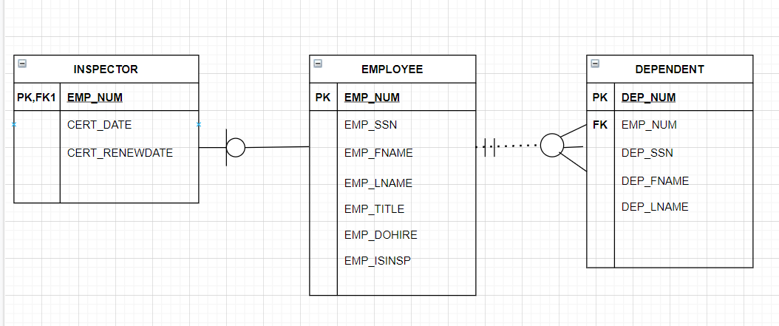

5) Given the following business scenario, create a Crow’s Foot ERD using a specialization hierarchy if appropriate. Tiny Hospital keeps information on patients and hospital rooms. The system assigns each patient a patient ID number. In addition, the patient’s name and date of birth are recorded. Some patients are resident patients who spend at least one night in the hospital, and others are outpatients who are treated and released. Resident patients are assigned to a room. Each room is identified by a room number. The system also stores the room type (private or semiprivate) and room fee. Over time, each room will have many patients. Each resident patient will stay in only one room. Every room must have had a patient, and every resident patient must have a room.

**Answer: -**

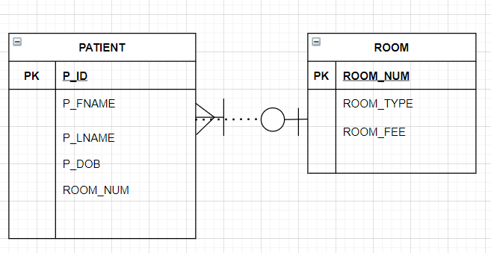

**Chapter 4**

2.

Create a complete ERD in Crow’s Foot notation that can be implemented in the relational model using the following description of operations. Hot Water (HW) is a small start-up company that sells spas. HW does not carry any stock. A few spas are set up in a simple warehouse so customers can see some of the models available, but any products sold must be ordered at the time of the sale.

• HW can get spas from several different manufacturers.

• Each manufacturer produces one or more different brands of spas.

• Each and every brand is produced by only one manufacturer.

• Every brand has one or more models.

• Every model is produced as part of a brand. For example, Iguana Bay Spas is a manufacturer that produces Big Blue Iguana spas, a premium-level brand, and Lazy Lizard spas, an entry-level brand. The Big Blue Iguana brand offers several models, including the BBI-6, an 81-jet spa with two 6-hp motors, and the BBI10, a 102-jet spa with three 6-hp motors.

• Every manufacturer is identified by a manufacturer code. The company name, address, area code, phone number, and account number are kept in the system for every manufacturer.

• For each brand, the brand name and brand level (premium, mid-level, or entry level) are kept in the system.

• For each model, the model number, number of jets, number of motors, number of horsepower per motor, suggested retail price, HW retail price, dry weight, water capacity, and seating capacity must be kept in the system.

**Answer:**

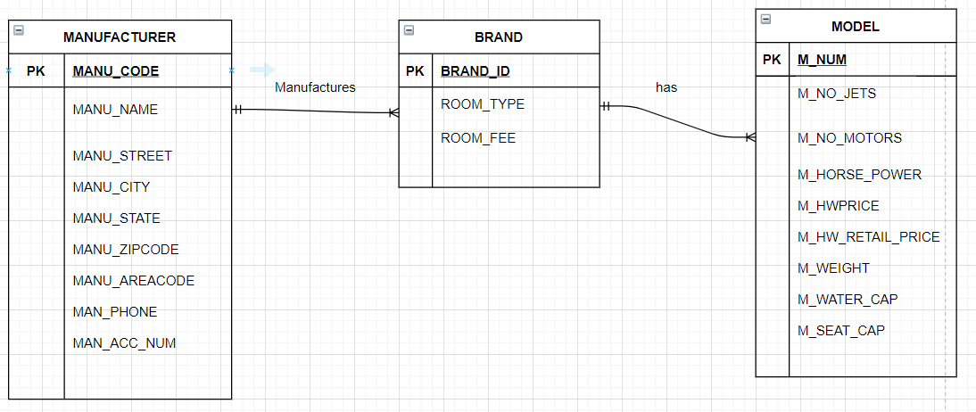

1. Use the following business rules to create a Crow’s Foot ERD.

Write all appropriate connectivity’s and cardinalities in the ERD.

A department employs many employees, but each employee is employed by only one department.

Some employees, known as “rovers,” are not assigned to any department.

A division operates many departments, but each department is operated by only one division.

An employee may be assigned many projects, and a project may have many employees assigned to it.

A project must have at least one employee assigned to it.

One of the employees manages each department, and each department is managed by only one employee.

One of the employees runs each division, and each division is run by only one employee.

**Answer:**

1. The Jonesburgh County Basketball Conference (JCBC) is an amateur basketball association. Each city in the county has one team as its representative. Each team has a maximum of 12 players and a minimum of 9 players. Each team also has up to 3 coaches (offensive, defensive, and physical training coaches). During the season, each team plays 2 games (home and visitor) against each of the other teams. Given those conditions, do the following:

• Identify the connectivity of each relationship.

• Identify the type of dependency that exists between CITY and TEAM.

• Identify the cardinality between teams and players and between teams and city.

• Identify the dependency between COACH and TEAM and between TEAM and PLAYER.

• Draw the Chen and Crow’s Foot ERDs to represent the JCBC database.

• Draw the UML class diagram to depict the JCBC database.

**Answer:**

